# Setting Up A Raspberry Pi For Automotive (1.0)

This guide will show you how to set up a raspberry pi connected to a display for automotive use, including installing a my app to read some vehicle sensor data over an OBD2 bluetooth scantool. To complete this guide, you will need:

* Some knowledge of electronics and software
* Basic shop tools
* Various screws, spacers, and washers in M2, M3 and M4 sizes
* [Silicone](https://smile.amazon.com/gp/product/B0002BBX3U/ref=oh_aui_detailpage_o02_s00?ie=UTF8&psc=1) to keep water out of the LCD
* [2 USB micro](https://smile.amazon.com/gp/product/B00MVAO742/ref=oh_aui_detailpage_o00_s01?ie=UTF8&psc=1) and [1 HDMI](https://smile.amazon.com/ECHOGEAR-Ultra-Slim-Flexible-Cable/dp/B016CIYOAA/ref=sr_1_1?s=electronics&ie=UTF8&qid=1498704407&sr=1-1&keywords=flexible+6+foot+hdmi+cable\) cable (one of the USB cables may need to be spliced into something)
* [A 12 to 5V stepper or LDO rated for automotive use](https://smile.amazon.com/gp/product/B00O6R9PCC/ref=oh_aui_detailpage_o02_s00?ie=UTF8&psc=1)
* [A micro tap a fuse](https://smile.amazon.com/gp/product/B01LFXA5YQ/ref=oh_aui_detailpage_o00_s00?ie=UTF8&psc=1) and wire to splice with
* [1 Raspberry Pi 3](https://smile.amazon.com/gp/product/B01CD5VC92/ref=oh_aui_detailpage_o08_s00?ie=UTF8&psc=1)
* [Waveshare 7 inch HDMI display](https://smile.amazon.com/gp/product/B01HPV7KL8/ref=oh_aui_detailpage_o06_s00?ie=UTF8&psc=1)
* [32 GB sd card](https://smile.amazon.com/gp/product/B06W2LKXYY/ref=oh_aui_detailpage_o03_s00?ie=UTF8&psc=1)
* [1 Anti-Glare screen protector](https://smile.amazon.com/gp/product/B005QCDY50/ref=oh_aui_detailpage_o01_s00?ie=UTF8&psc=1)
* [USB Bluetooth dongle](https://smile.amazon.com/gp/product/B010AX4WG4/ref=oh_aui_detailpage_o09_s00?ie=UTF8&psc=1)
* [Scantool obdlink mx](https://smile.amazon.com/gp/product/B006NZTZLQ/ref=oh_aui_detailpage_o09_s00?ie=UTF8&psc=1)

## Step 1: Setting up IoT

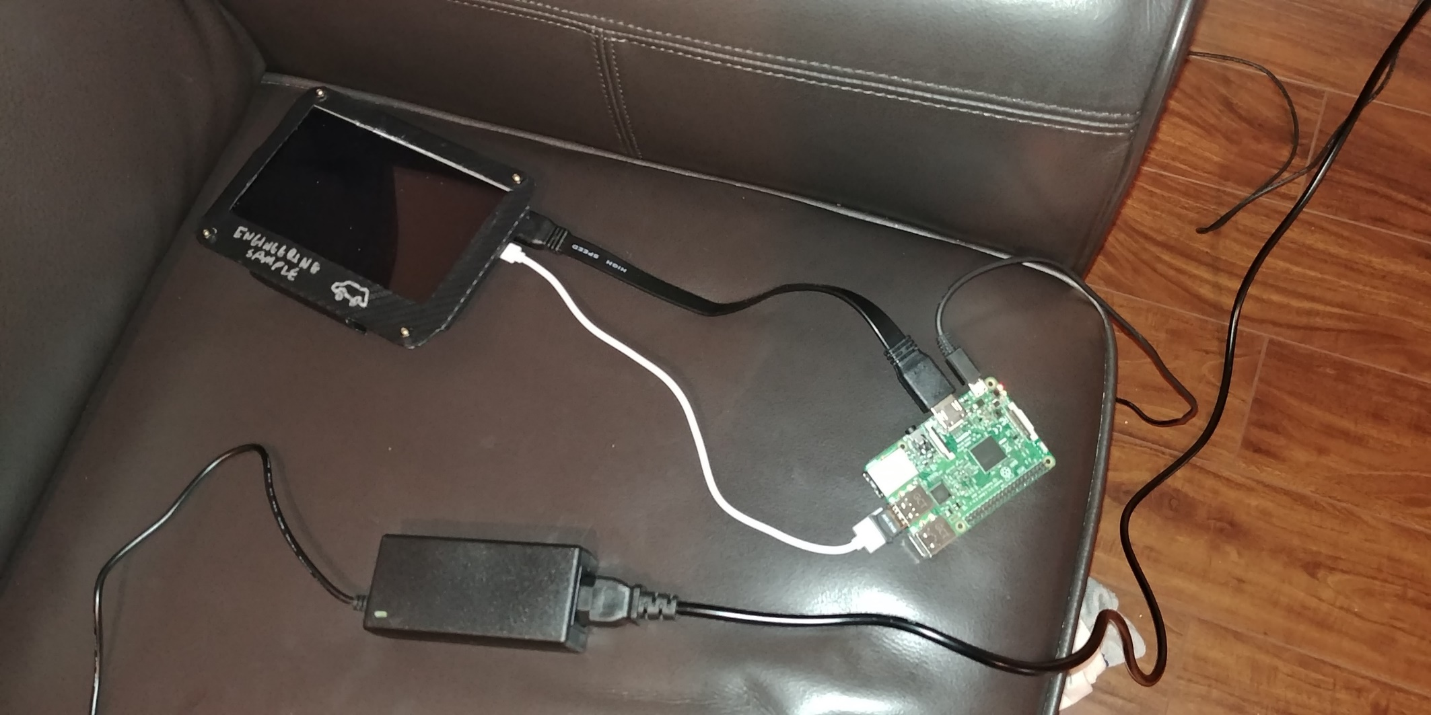

Figure 1 My test bench

Connect the Raspberry Pi to the HDMI display and Bluetooth dongle in the manner shown. Before we can power the raspberry pi on, we need to install an OS for it as well as change some of the configuration settings in the bootcode to make it play nice with the display. Insert the SD card into your laptop, then get the IoT installer for the Raspberry Pi [here](https://developer.microsoft.com/en-us/windows/iot/Downloads) and open the IoT Core Dashboard:

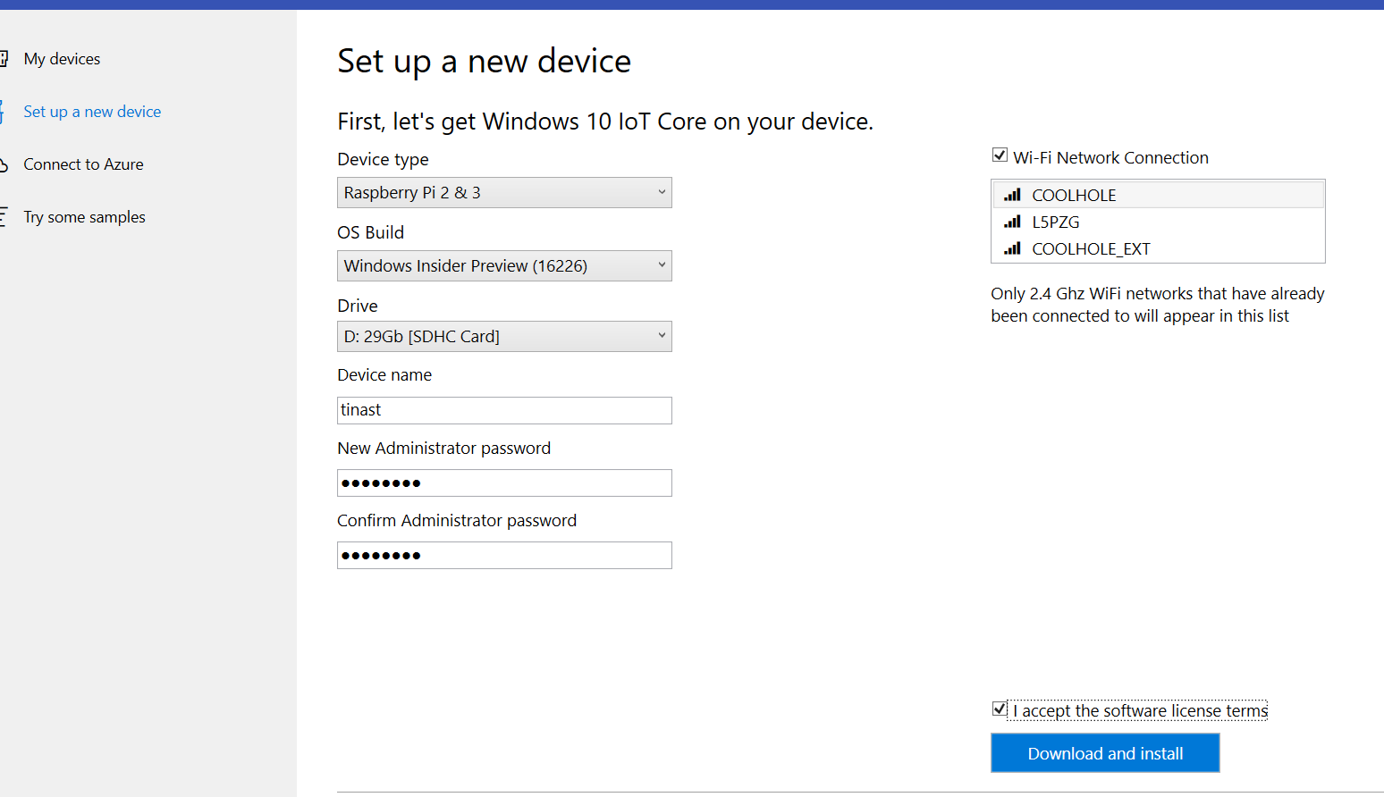

Figure 2 IoT dashboard

Click “Set up a new device” and configure it in the manner shown. You need the wifi connection to match the connection your laptop uses to configure it later on. When ready, click Download and Install to flash the OS to your SD card. Once you’ve downloaded, the OS, you’ll need to make some modifications to the config.txt in the root of the SD card. Open the EFIESP and edit the config.txt file:

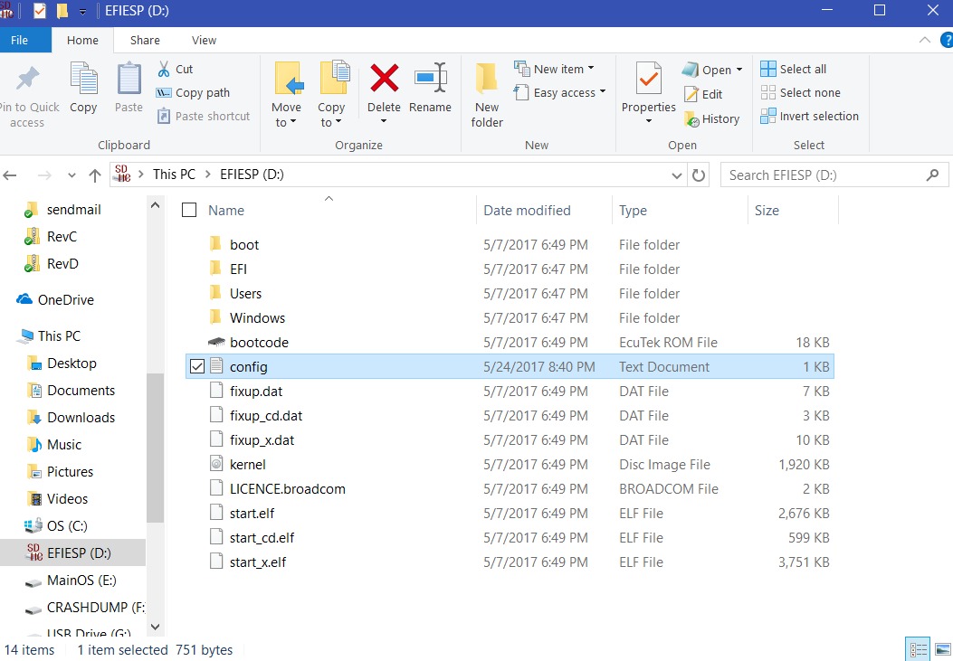

Figure 3 The config.txt file

Append the following lines to the config.txt, removing any duplicate config.txt entries that were already there and removing the existing hdmi_cvt entry:

hdmi_mode=16

hdmi_drive=1

hdmi_force_mode=1

Note that the bottom 168px of the frame won’t be visible since the native resolution on the 7-inch LCD is 600p, not 768. Remove the SD card from your system and insert it to the Raspberry Pi, then proceed to power it on with it connected to the same network router as your laptop. When it gets to OOBE (the first blueish looking menu after the Windows logo asking you for stuff like your language and Wifi access point) open up IoT core dashboard and look for the device in the My Devices menu:

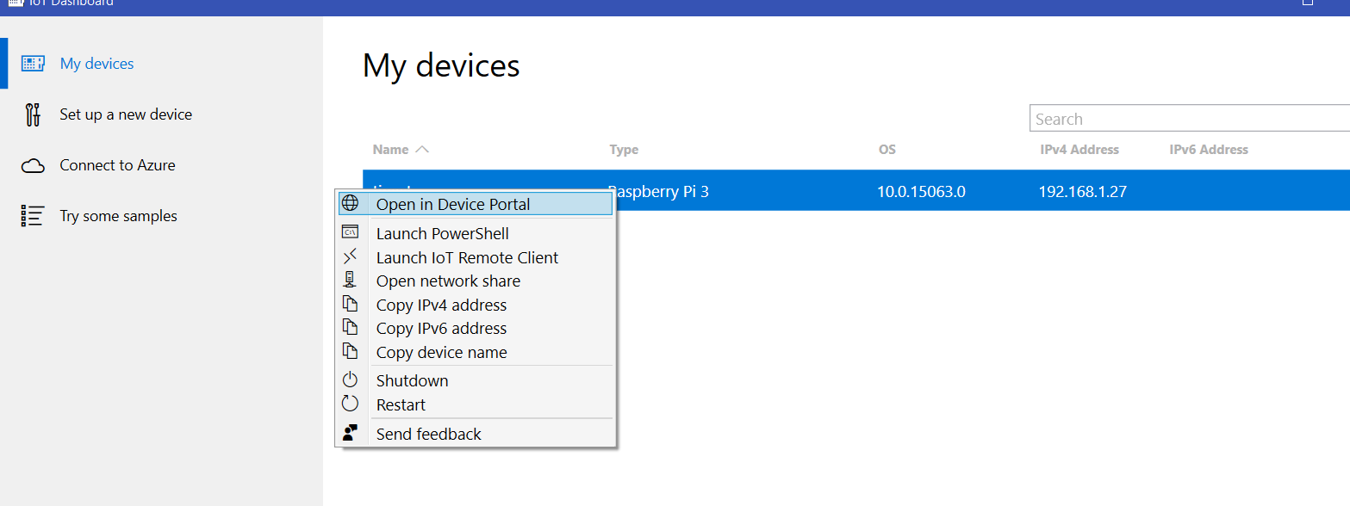

Figure 4 Connecting to the device in Device Portal

From the Device Portal webpage, enter your administrator password and go to the Apps manager by clicking Connectivity > Bluetooth. Go to Processes > Run command, then type in “devcon disable BCMBTBUS\BLUETOOTH”. Note: *This is an important step. To work around limitations in the Raspberry Pi’s builtin Bluetooth radio, this disables the onboard radio so that pairing will take place with the USB Bluetooth radio.* When the onboard radio is disabled, click the OBD2 scantool you want to pair, then follow your manufacturer’s instructions to pair it:

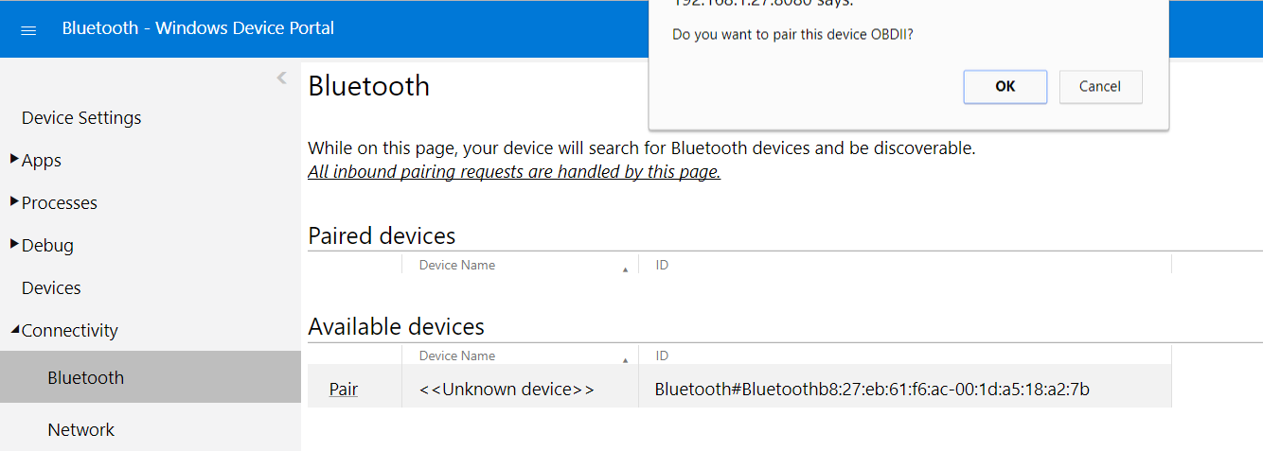

Figure 5 Pairing with a bluetooth device.

Once it’s paired, go to the Apps > Apps Manager menu. Locate the app package to install and install it by choosing the appropriate file and certificate using the menu buttons. Click go to install the app:

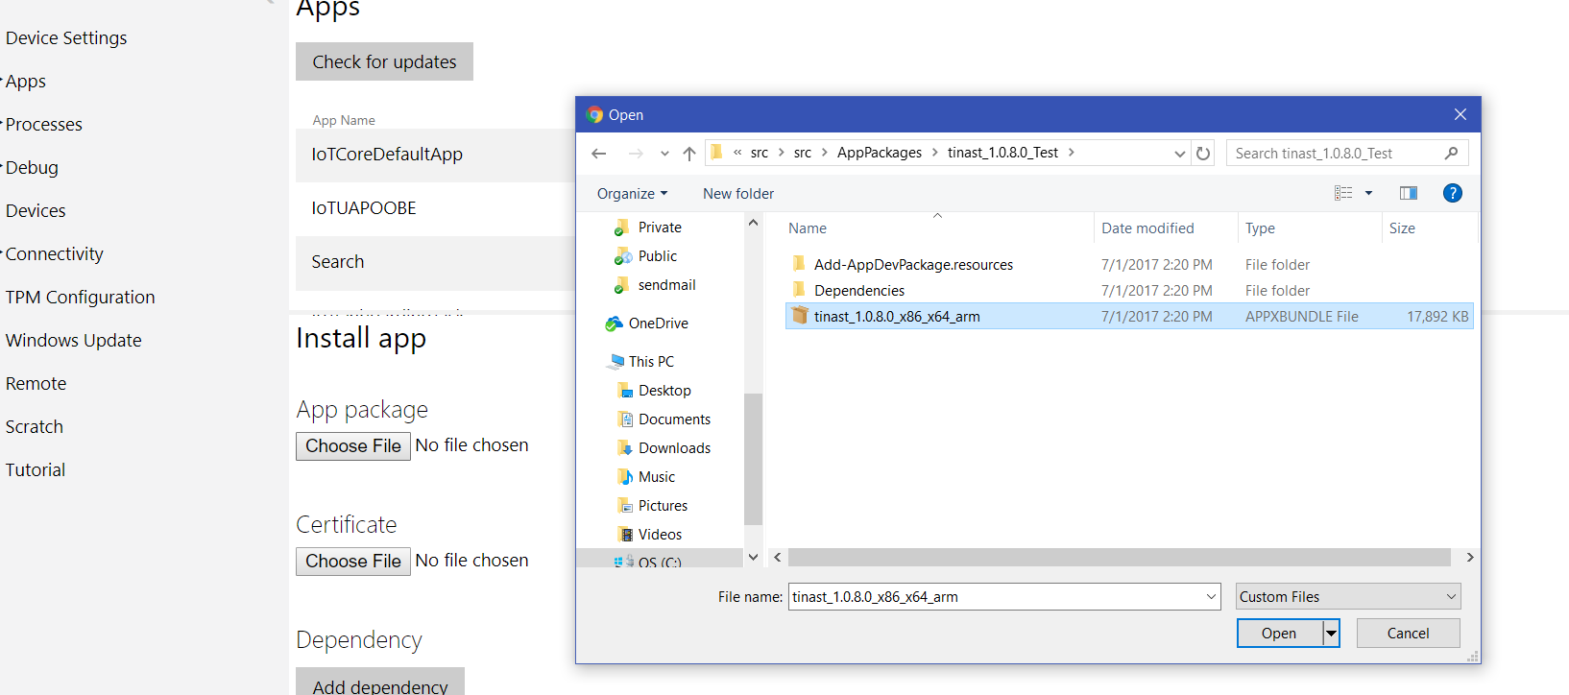

Figure 6 Installing an app

Make sure you install the appxbundle, certificate, as well as the dependencies contained in the package:

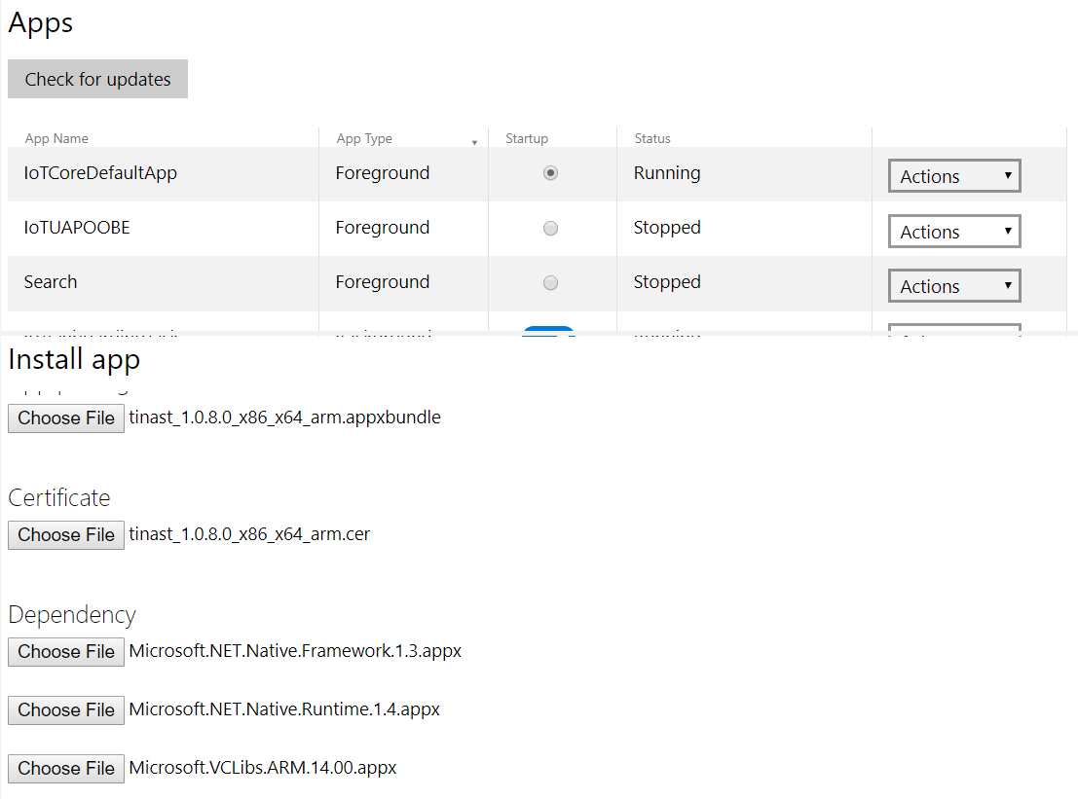

Figure 7 Apps, certificates, and dependencies

Once deployed, click the radio button next to “Foreground” in the app list for the app. That will make it run automatically on startup.

## Step 2: Wiring it up

Cool man.

Now that you have your Raspberry Pi brought up to run an app at startup and paired it with your scantool, the next step is to wire it into the vehicle. You’ll need to put together your mounting hardware, power supply, and probably some soldering equipment for this. For the power supply, I really recommend an LDO to cut down on flicker going to the display, but I picked a stepper. I can’t offer much in detail advice on how to mount this. The first figure in this guide shows how I did it, but I’m not a metal working genius by any means. One of the pictures below will show the improved version I’m currently running in my vehicle. In general, I recommend some sheet metal, a hammer, flat corner of a table, Dremel, epoxy or bondo, tin snips and patience.

The guide below will walk through how I configured it and mounted it in my vehicle. I chose to mount it on the facia covering the passenger side dash, as that was an easy to replace part in the event I messed something up and provided easy cabling access to the dashbox which I use as a service point for the raspberry pi assembled above. You’ll have to make sure you angle the screen correctly wherever you mount it. For instance, to avoid glare obscuring the instruments. To start with, take your LCD display and cover the edges in silicone to prevent water damage from seeping into it. Then apply the anti-glare screen to it and mount it to the gauge fixture. Once you’ve gotten your gauge fixture set up with the screen installed to it, you’ll end up with something like this:

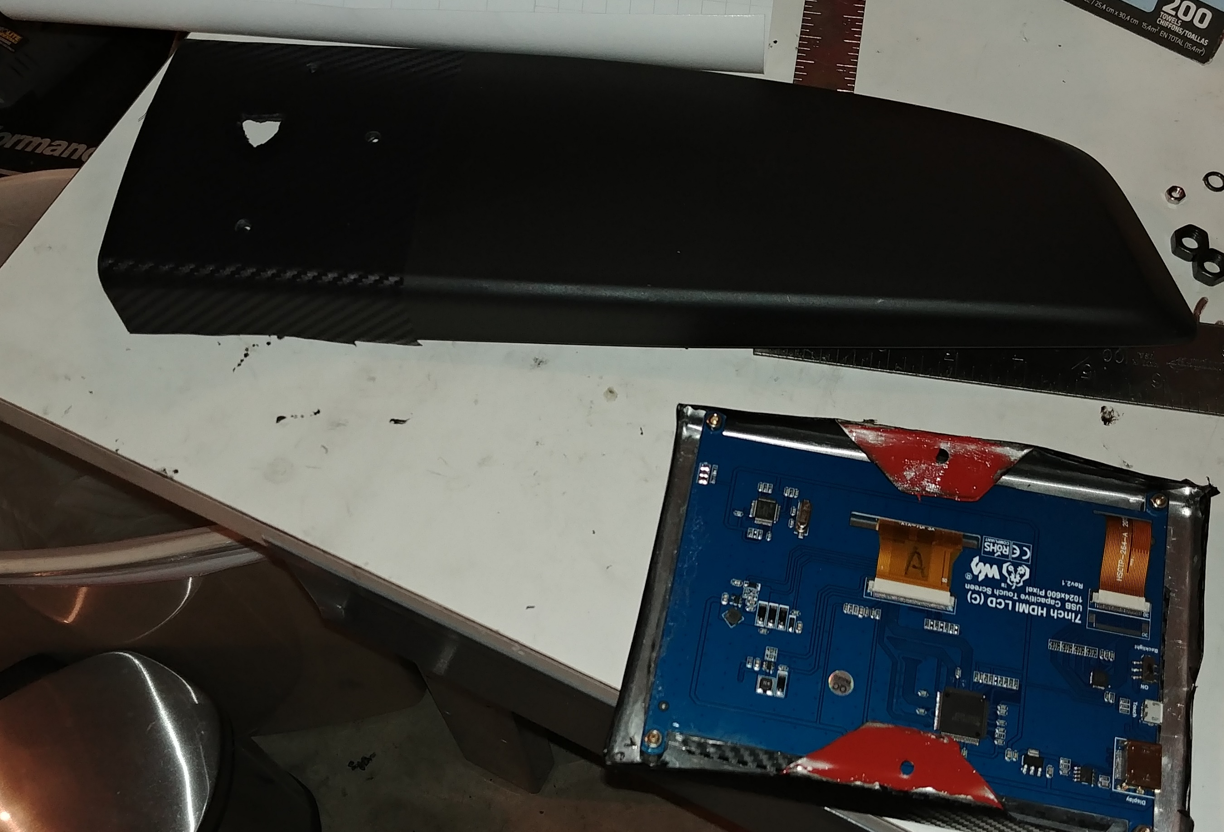

Figure Building a display fixture

Mount your gauge fixture back onto the vehicle, using bolts (or in my case tape and the plastic clips) to secure it to the vehicle. Route the HDMI and USB cable in the manner shown, behind the passenger side dash fascia and down into the glovebox:

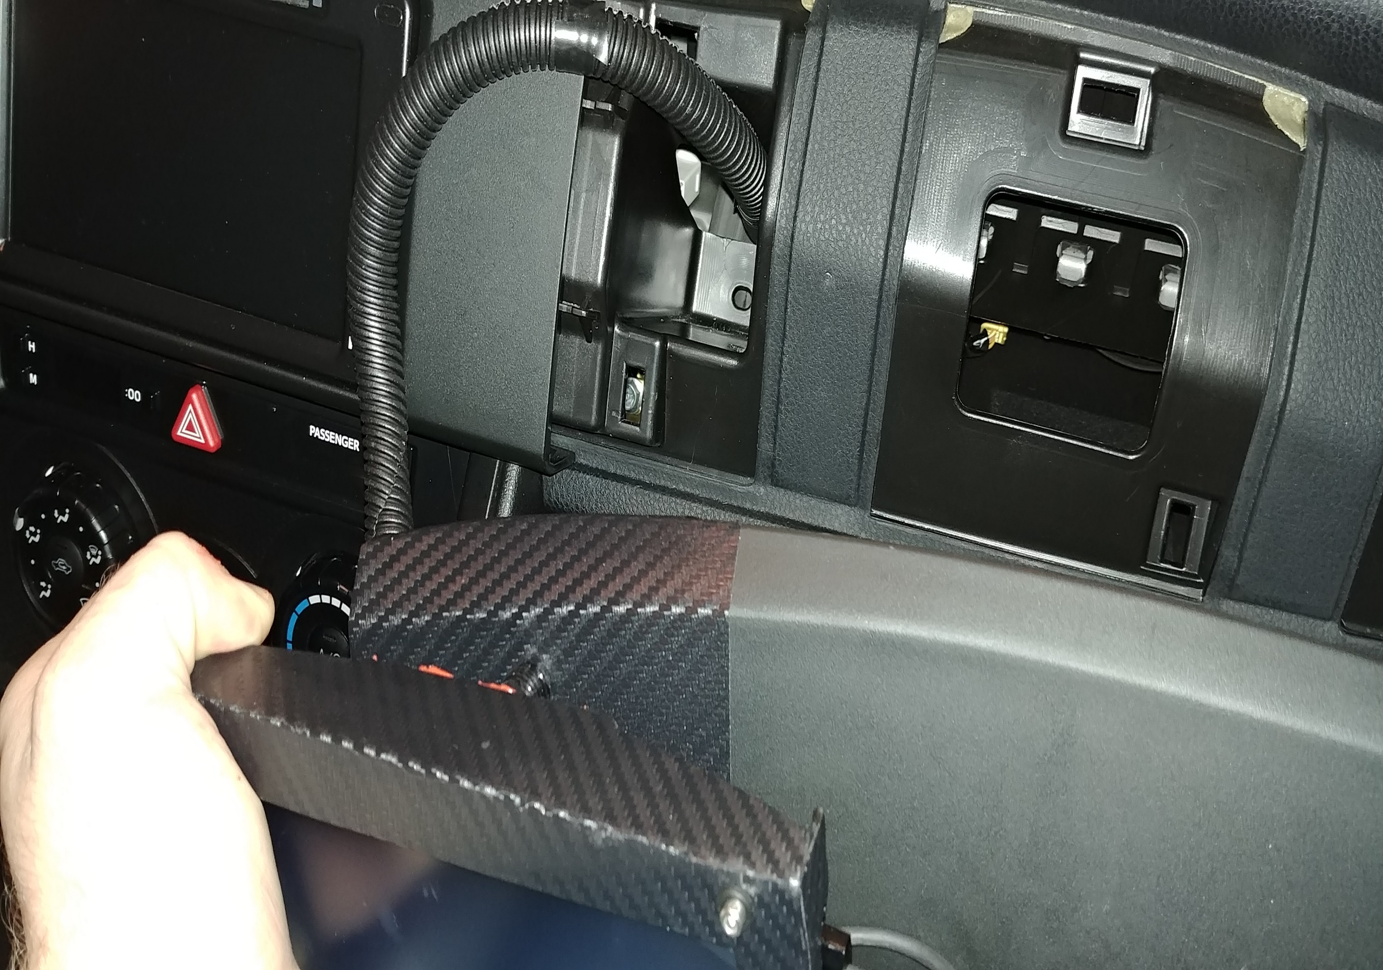

Figure Attaching the gauge to the vehicle.

Connect the Raspberry Pi to the cables from the last step in the glovebox, and then begin routing the power cable from the passenger side to the driver side of the vehicle to access the fusebox there. There should be a passage to the driver side visible when you remove the glovebox and shine a light on the other end. It located, might take some trial and error to find the proper routing:

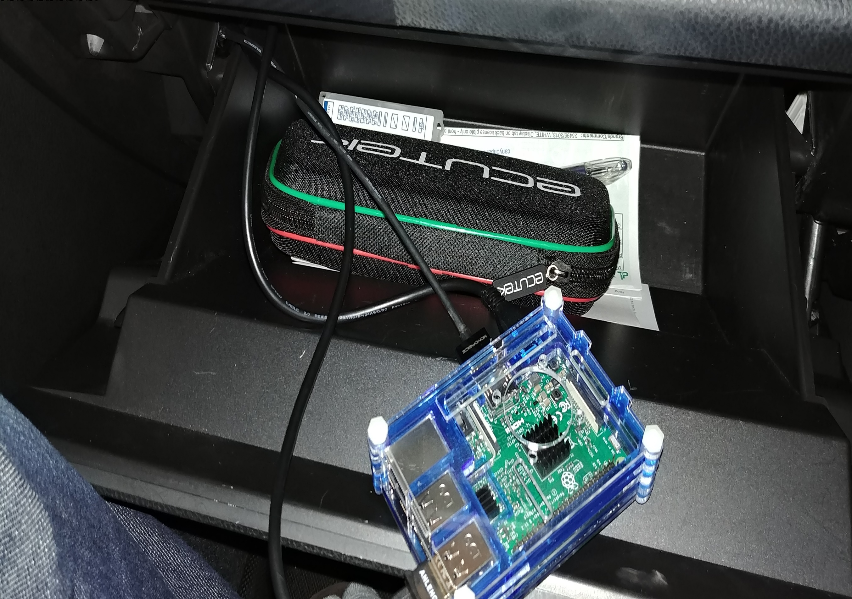

Figure Installing the Raspberry Pi.

Access the driver side fusebox by removing the cover under the steering wheel. Tap out the radio fuse to the stepper you install under the dash, then connect a ground wire to the chassis. Connect the USB +5V and GND lines appropriately to the stepper. Connect your OBD2 scan tool to the vehicle’s OBD2 interface. When done, your routing will look something like the below. In my example, I also tapped 12V out from the OBD2 connector I installed to the radio fuse to avoid parasitic power drain on the battery by opening the switch on my OBD2 cable and re-soldering the +12V wire to an external wire going to a distribution bus going to the radio fuse:

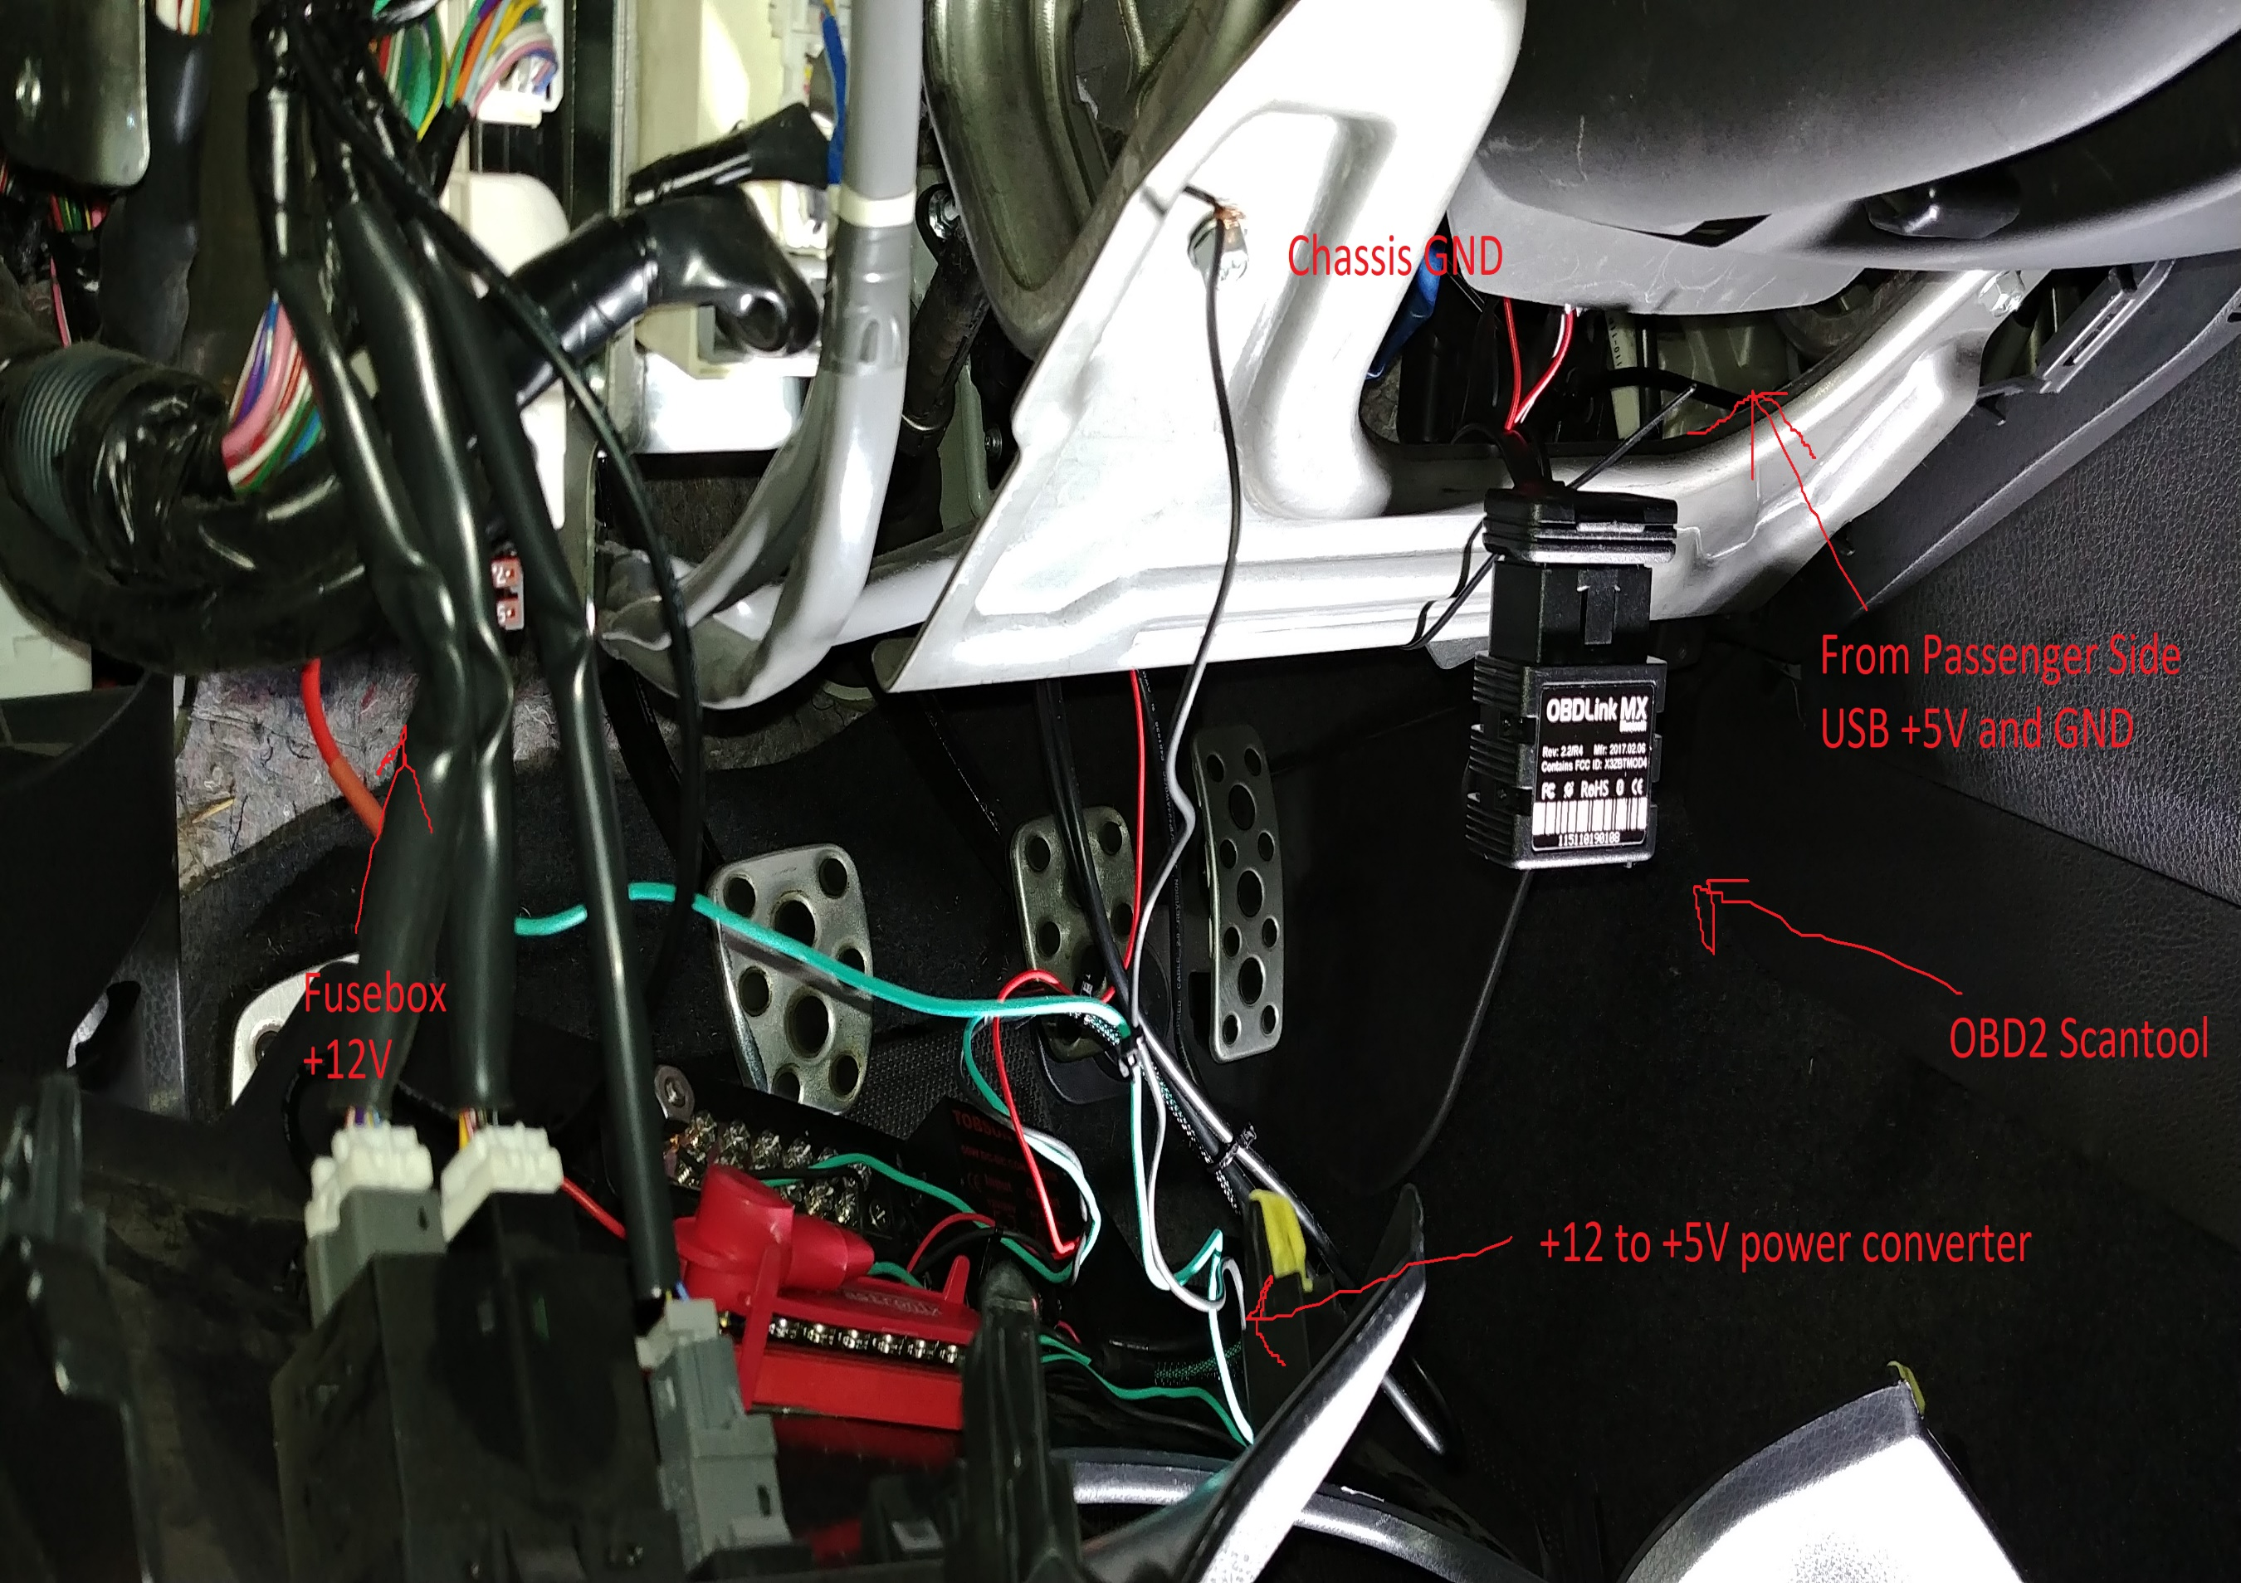

Figure Connecting to the vehicle

Reassemble the dash cover. You’ll end up with something looking like the below. Proceed to start your vehicle and see if the new gauge works or not:

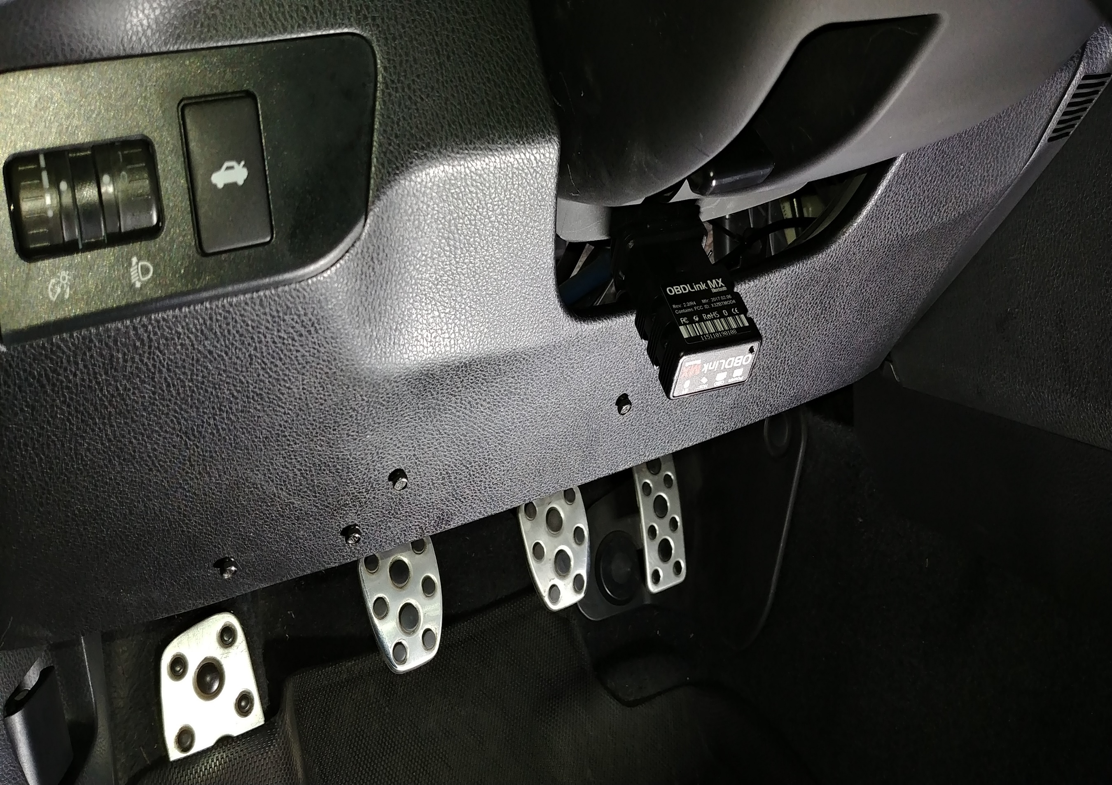

Note that when you start the car there will be 2 power cycles for the Raspberry Pi when it’s connected to the radio fuse in this way from key off to ignition. I’m still experimenting with ways to smooth this power level out; connecting 12V to the battery and using the radio fuse as a relay signal might work better for you. For me, I intermittently have to open the glove box after the car is running and just reset the power connector on the Raspberry Pi if it’s having trouble booting [you’ll know if it’s not booting if the red LED is blinking a trouble code periodically]. Alternatively, simply connecting the 5V supply to a toggle switch or backup battery may be a more straightforward method of working around this.